*Bioinformatics*, 2017

Delft Bioinformatics Lab: April, 1st 2017

|  |
| --- |
| Genome assembly  Improving short reads aneuploid assembly: An improved ploidy estimation method and some polyploid phasing perspectives.  Mel Carbajo Martínez*1, Thomas Abeel1  1The Delft Bioinformatics Lab, Faculty of Electrical Engineering, Mathematics and Computer Science - Intelligent Systems, Delft, The Netherlands.  *To whom correspondence should be addressed.  Abstract  **Motivation:** With the decreasing cost and increasing read length of next-generation sequencing technologies, newer higher quality draft genome sequences are being published at increasingly faster rate. With well-established methodologies, larger and more complex genomes are being tackled. However, the ploidy of the genome (the copy number of its chromosomes) greatly affects the accuracy of the assembly. While genomes with only one or two copies of each chromosome (haploid or diploid) have existing efficient methodologies to assemble them, polyploid (constant ploidy higher than two) and aneuploid (variable copy number per chromosome) haplotyping are much more challenging to solve. Given the similarity between multiple copies of a basic genome in polyploid individuals, assembly of such data usually results in collapsed contigs that represent a variable number of homologous genomic regions. Such collapse is far from ideal, as the corresponding lost information lead to inaccurate assemblies and a corresponding lack of precision in understanding how haplotypes influence phenotype. Nearly all previous haplotype reconstruction studies have focused on diploid genomes and are rarely scalable to genomes with higher ploidy. Yet computational investigations into poly and aneuploid organisms carry great importance.  **Results:** Here, I’ll describe a method to improve the quality of short reads aneuploid genomes assembly by estimating the copy number of their different contigs. Pedca (Ploidy Estimation by Dynamic Coverage Analysis) infers the ploidy of the fragments by analyzing the coverage distribution of the aligned reads and the ratio among its clusters. I also briefly describe a draft complementary methodology for polyploid phasing that avoids the exponential computational calculation of all possible haplotype combinations. As a proof of concept, Pedca is tested on simulated as well as real sequencing data from CBS1483 (S.pastorianus yeast). Finally we apply our method to infer the chromosome copy number of Trypanosoma cruzi CL Brener which has never had any rigorous estimation before**.**  **Availability:** Both Pedca and PolyHap-G can be downloaded for free at : https://github.com/MelMartin/Ploest.git  **Contact:** mel.carbajo.martinez@gmail.com  **Supplementary information:** Supplementary data are available online. |
|  |

# Introduction

Diploid organisms, like humans have two copies of each of its chromosomes. While most of both strains genetic sequence is the same, differences among each copy appear at specific loci. Other organisms like many prokaryotes and certain animals and plants (among them many important crop plants like wheat, potatoes, oat or soy) are polyploid (“The Polyploidy Portal,” n.d.) , which describes a constant number of chromosomes (higher than 2) for the whole genetic content. Following the same logic, an aneuploid genome has an irregular copy number for each of its chromosomes, with different levels of heterozygosity.

The differences among the copies might range from one single nucleotide or SNP (the most frequent type, including deletions or inserts) to very large structural variations (duplications, translocations, inversions…) *Genotype calling*, reports the variant sites without associating them to an specific allele, while *haplotyping* or *phasing* provides the order of the variations in each allele. This extra information is crucial for understanding the potential different gene expressions of the haplotype, which affect the metabolism of the organism. Fundamental applications rely on this description, from determining the appearance or absence of physiological traits, to identify different susceptibility to diseases, treatments or understanding recombination patterns of genetic inheritance (Wagner, n.d.).

Finding methods specifically targeting the detailed sequence analysis of aneuploid genomes is a central challenge to understand these organisms. Many types of yeast, which are used for a large number of biological applications like fermentation, or bio-fuel and biopolymers production, have aneuploid genomes.

To sequence a given genome, multiple copies of its DNA are segmented into a large amount of reads. Current algorithms reconstruct the original genome in a single sequence based on the consensus of the most represented variations in the overlapping reads.

Since aneuploid organisms have a varying chromosome copy number, it is necessary to infer the correct ploidy for each chromosome. While parallel regions among different copies of a particular chromosome are by definition very similar, each copy is likely to have its own specific variations. Averaging intra-chromosomal variations therefore results in a flattened homomorphic genome with a consequent lost of information.

The goal introduced in this proposal is to come up with a more accurate and detailed assembly than one obtained by simply flattening variations into a consensus sequence. We propose an improved method to allow detailed copy number estimation per contig in de novo aneuploid assemblies. Our method presents itself as a .jar file that works on any operating system with a java platform. It only requires as an input an alignment file (.bam or .sam) of short reads mapped to a draft reference assembly. We demonstrate its performance by inferring the ploidy of a set of simulated chromosomes and utterly by applying it to the genome of the yeast S. pastorianus strain CBS 1483. An optional complementary analysis can be obtained if a variant call file (.vcf) is provided.

A consensual assembly describes a fair approximation of a genome where only the most frequent variations are represented. When a new assembly is performed, the small differences corresponding to the specific individual genetic signature of the specimen will arise, but when reconstructing the genome, the small reads have to be merged into longer contiguous sequences called contigs. The general approach is to flatten out differences by consensus. The most represented variations will determine the consensual assembly with the subsequent less represented variations being flattened and disapearing. We use the term *draft reference* or *consensual reference* to the sequences obtained using such method.

In order to work, Pedca needs to map the reads to a reference genome. If no reference genome is available, a draft reference can be provided or built with a de novo assembler. We used the Newbler software package (454 Life Sciences, Branford, CT), for assembling Illumina short reads libraries, but there is a large range of choice for this step.

To establish the correct variation within chromosome copy numbers we use an improved variation of the Magnolya algorithm (Nijkamp et al., 2012) to estimate the copy number of a contig. Inferring chromosome copy numbers doesn’t provide information on variations among sequences.

Variant calling is then performed with Pilon (Walker et al., 2014), detecting heterogenic variance along the draft reference genome. But simply having the list of variations relative to a draft consensual genome doesn’t describe the detailed haplotypes of each chromosome copy.

In order to determine which combination of variations describes an haplotype, we need to have long enough reads. We then describe some steps taken towards a new approach on polyploid phasing that optimizes the variant information obtained from the alignment, grouping SNP’s together in their respective strain.

# Methods

### 2.1 Simulated DNA sequence data. Building a realistic simulated S.*pastorianus* genome

In order to validate our model we build a simulated aneuploid dataset of 5 different chromosomes with different copy numbers each. Three chromosomes have a copy number of 3, one chromosome has 2 copies and the last one has 4. Every different copy of each chromosome has its own set of specific variations.

In order to build our simulated data with a structure as close as possible to a real genome we build them using real sequenced Illumina reads (four libraries of different insert sizes) from *S.pastorianus* CBS1483*.*

The real libraries used to build our simulation are the same used by (van den Broek et al., 2015). They were obtained sequencing a CBS1483 genome, using an Illumina HiSeq2000 sequencer (Illumina, San Diego, CA) at BaseClear (Leiden, The Netherlands). A total of four paired libraries with different insert sizes were obtained. Two 100-cycle paired-end libraries with insert sizes of 500 and 180 bp and two 50-cycle mate pair libraries with 3- and 8-kb insert sizes were sequenced. The combined libraries comprised more than 10⁸ reads, which represent approximately 7 Gb, resulting in a genome coverage of +/-270 times (see Table in the supplemental material).

We know that *S.pastorianus* is an hybrid of two ancestral parent yeast, *S.cerevisae* and *S.eubayanus* (Libkind et al., 2011)*.* While we don’t have a complete genome sequenced of the second, we have a full annotated genome of the first one, *S.cerevisae.* We selected as a reference, 5 chromosomes of *cerevisiae* (I, II, III, IV and X) known to have different copy numbers presence in the *pastorianus* genome. Chromosome X has also a small structural variation which is representative of hybrid genomes which will allow us to evaluate our results comparing them to previous studies(van den Broek et al., 2015). Using bwa-0.7.13, we mapped the four libraries of *pastorianus* Illumina reads to the *cerevisiae* reference. The resulting .bam files represent only the genetic heritage of the hybrid genome that maps to the corresponding *cerevisiae* chromosomes.

The mapping accepts a certain degree of mismatches in its alignment which is interesting to us because it allows mapping those reads with small variations to regions that have been flattened and lost their alternative alleles in the consensual assembly. Whenever a loci has different sequence per haplotype, the assembler retains the most represented one, disregarding the minorities. We recover the diversity present in the original reads by performing variant calling over the *pastorianus* reads mapped to the *cerevisiae* reference (see statistics on supplemental material). All the variations (about 3% of the genome’s positions) are reported in their corresponding .vcf files.



**Figure 1** The hybrid nature of S.*pastorianus* allows us to reconstruct a reliable simulated genome based on the ancestral genetic heritage of the *cerevisiae* chromosomes. Aligning S.pastorianus reads to S.*cerevisiae* reference allow measuring the variations currently present in the real *pastorianus* genome. The result of the base calling reflects the alternative alleles at the heterozygous positions of the haplotypes, which are stored in the corresponding .*vcf* file to be used utterly in the construction of the simulated data.

We also build our simulation based on the S. *pastorianus* chromosome copy numbers reported byvan den Broek et al., but introduce the variations at the precise loci where they are detected by Pilon. Because we don’t know the haplotype to which each variation belongs, we attribute them randomly among all the possible copies of each chromosome. ()

Once each different copy of each simulated chromosome was defined, we simulated sequenced reads from them. We ran ART (Huang, Li, Myers, & Marth, 2012) with the HS20 platform profile that is provided with the simulator for paired-end reads. ART requires three parameters, the coverage c of each haplotype, the mean insert length f and the standard deviation of insert length, to generate paired-end reads. We measured these parameters in our CBS1483 libraries and recreated the simulated reads with similar values (see supplemental materials).



**Figure 2** Introducing measured variations into simulated alleles. For every variation position detected, the same rounded proportion of bases is reintroduced. For example, the first position reports a variation of approximately 1/3 of C’s, 1/3 of G’s and 1/3 of T’s, each of which are randomly assigned to any of the three copies of that contig. The second position reports a different ratio of approximately 2/3 C’s and 1/3 of G’s. Our final simulation contains the same degree of allele frequencies than the original, and at the same exact positions.

### 2.2 Real DNA sequence data

We use two other datasets to test our method, both of S.*pastorianus* strain CB1483. The first is the same one that we’ve used as a base to build the simulated dataset described above. Using sequenced Illumina reads (four libraries of different insert sizes) from *S.pastorianus* CBS1483(described in detail in the supplemental material) We’ll refer to this sequencing as the BaseClear CBS1483.

We also have a version of the CBS1483 strain sequenced by the company Novogene that for some reason has previously been discarded in previous ploidy estimation studies (van den Broek et al., 2015). We’ll use this data set to test the limits of our method since we expect it to be very noisy. We’ll refer to this reference as the Novogene CBS1483.

### 2.3 Consensual draft reference genome

We assembled our simulated dataset using three different de novo assemblers: Newbler, SOAPdenovo and ALL-PATHS. Newbler is a standard 454 Illumina assembler which is based on the overlap-layout-consensus algorithm. ALL-PATHS is specially designed to assemble Illumina GA short reads and is based on a de Bruijn graph approach (Butler et al., 2008). According to its authors, ALL-PATHS is suitable for large genomes up to human size. SOAPdenovo (Li et al., n.d.) also works using a de Bruijn graph using pre-set thresholds for K-mer frequencies.

We mapped the results of our assembled contigs to the references, and analyzed the errors with Quast (Gurevich, Saveliev, Vyahhi, & Tesler, 2013).

Allpaths managed to obtained 61 contigs with a total of an N50 of 133464bp. Newbler’s assembly resulted in 558 contigs, almost 10 times more scatter than Allpaths’. Its contigs were considerable smaller in average with a N50 of 10800bp, but with a remarkable absence of any misassemblies errors (relocations, translocations and inversions). A SOAPdenovo assembly was also performed with less satisfying results .

Since our simulated dataset is very close to the real *pastorianus* data that we want to solve, we chose the Newbler assembly with zero misassemblies over Allpaths 5% supplemental mapped genome that would likely be provided with assembly errors.

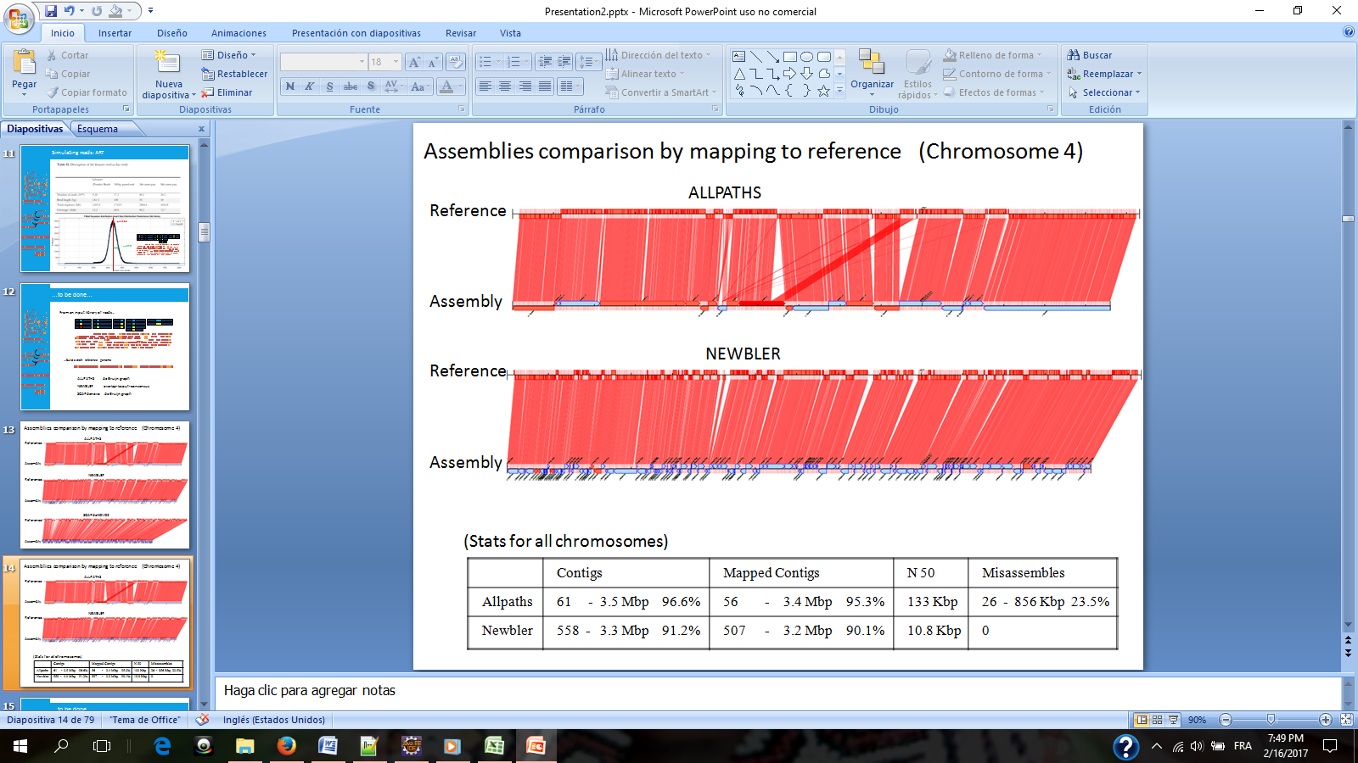

**Figure 3** A visual comparison among both Allpaths and Newbler assemblies of our simulated chromosome 4. The top horizontal sequence of each diagram represents the reference genome, the bottom line shows the contigs, red lines map the contigs to the correct position in the reference (visualization with Contiguator) It shows that while Allpaths have clearly longer contigs (bottom horizontal line) and a slightly more dense coverage of the reference genome (top) The table describe the results over all chromosomes combined. It is worth underlying that while the N50 is much lower with Newbler, the mapped reference genome is only slightly affected while the misassemblies drop drastically to zero.

Several runs of Newbler allowed measuring the optimal parameters to minimize the different errors and amount of unmapped contigs (See supplemental material). Comparing the different assemblies revealed common unmapped areas, independently from the software used. The optimal parameters we found confirm the settings used by (van den Broek et al., 2015). Nevertheless it is important to underline that these tests were performed to get to know our data better. Our method is completely independent from any particular assembler. The quality of the input draft reference genome affects the quality of the ploidy estimation in different ways. Error free contig will have ploidy estimations with no other ploidy fragmentation than the one due to internal structural variations, while low quality assemblies might merge sequences coming from different chromosomes that will lead to sudden jumps in ploidy within the same contig. The responsibility of the quality of the input draft reference is left to the user.

### 2.4 Ploidy Estimation.

Correct chromosomal copy number knowledge is a prerequisite to understanding a given genome. Knowing the ploidy of a sequence help us to search and identify the number of potential variations present in a segment. Those variations might be essential to understand the phenotypes of the organism. There are basically two approaches to solve the copy number problem: The stochastic model and coverage analysis.

2.4.1 The stochastic approach

ConPADE is a stochastic approach that estimates the ploidy of any given contig/scaffold estimates ploidy using the relative proportions of alleles in heterozygous positions along with a learned model of measurement error (Margarido & Heckerman, 2015). The intuitive explanation of this approach is that it tries to determine whether the observation of an alternative nucleotide reflects the presence of an alternative allele or is simply the result of an alignment or sequencing error. A model of probabilistic dependencies is built by taking into account features like the ratio between the two alleles, their own quality score of the read and the neighboring quality score, the GG content, and the observed and the reference nucleotide. Their own quality error is more complex than the simple quality score of the read which is a major strength of their approach. They use the model to infer the probability of observing each particular nucleotide in the dataset for all possible genotypes for any given ploidy, and subsequently infer the ploidy that maximizes the likelihood of the observed data.



**Figure 4** Magnolya’s fit of Poisson mixtures to the simulated dataset. Only the main peak (yellow) is identified and consequently, a copy number of 1 is wrongly identified for the whole dataset. The range of the x-axis is too large and all the clusters of the read count distribution are compressed in a relatively portion of the plot which doesn’t allow Magnolya to correctly fit the right number of Poisson mixtures.

We run ConPADE with our 4 libraries sizes, and we measure the likelihood for plausible ploidies from 1 to 4. ConPADE predicted well 4 out of 5 chromosomes in our simulated dataset. Their predictions were constant, for each chromosome the estimation was always the same independently from the library. It misestimated a copy number of 4 for chromosome 10, instead of the correct 2. We noted also that the likelihood estimations for different ploidies where very often very close to one another, which could lead easily to potential estimation errors (). ConPADE considers at most, only two possible alleles at any given position.

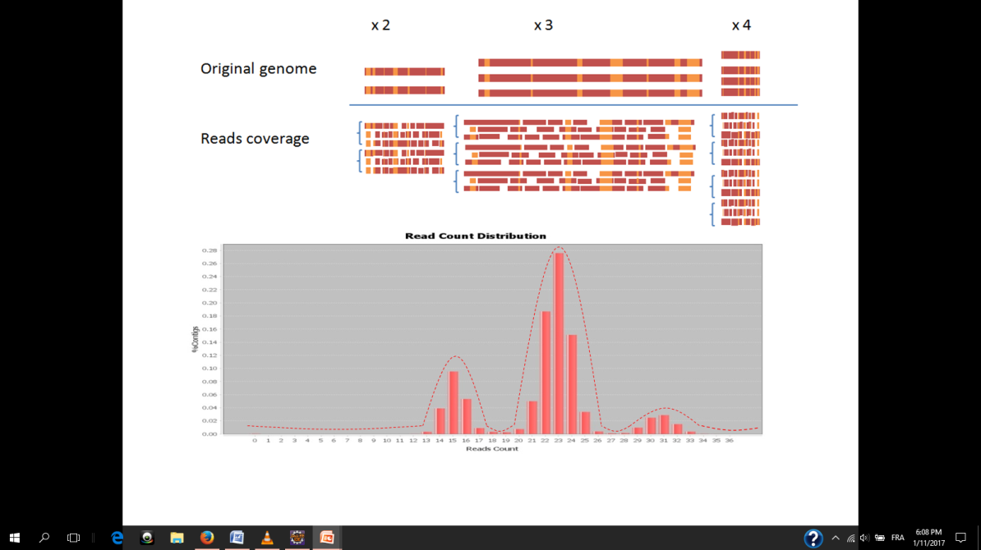

**Figure 5** The intuition behind ploidy estimation by coverage analysis. Regions with similar depth have similar read count (4.1 in the top). An increase in copy number corresponds to a proportional increment in the number of reads that map to the flattened reference of that region. Reads having same copy number cluster together around the same normal distribution. Reasoning in the opposite direction, the ratio between the centers of the clusters in the read count distribution allows the inference of the original copy number ratios and by extension their estimation (4.2 in the bottom).



**Figure 6** ConPADE ploidy estimation results on simulated data. On different library sizes the results were similar. For each chromosome the right copy number is indicated in parenthesis. In red, the lowest log likelihood (ConPADE’s prediction) for different possible copy numbers (1-4). Chromosomes 1-4 were correctly estimated. Chromosome 10 was predicted to have 4 instead of 2 copies.

2.4.2 The coverage analysis approach

Magnolya uses a Poisson mixture model for copy number estimation of contigs assembled from sequencing data. It infers the number of times a contig occurs in the genome from sequenced read depths. The intuition is quite straightforward: A chromosome with copy number *n* will have a proportionally higher number of reads that map to the flattened consensual reference of that region. The changes in the coverage over the genome follow a proportional ratio that allows the inference of the different copy numbers ( Top). Magnolya fits a mixture of Poissons to the read count distributions to obtain the center of the clusters, and from the ratios, it infers the different ploidies present in the genome ( Bottom).

While the underlying principle of Magnolya is quite solid, when the software is run on our simulated data set it is unable to detect the right copy numbers ().) Apparently, the three peaks that are supposed to be identified are there, but the x axis is so stretched that only the biggest central peak is recognized, and the two others, too close together, are discarded. Magnolya seems to have a problem when the x axis spreads over a large range, but most of the values are concentrated in a small portion of that range.

Pedca is built on the same principle that Magnolya, but with a few significant modifications. Pedca presents itself as an executable .jar file which allows it to run in any operative system with a java platform. It requires only one input: the bam/sam files of the contigs aligned to the draft reference genome. For our simulation and tests, we mapped our simulated reads described in section 2.1 against the simulated reference genome used to generate them.

2.4.3 Improvements to coverage analysis.

Because the coverage analysis is based on a very straightforward logic we want to find a way to improve its reliability and generalize the method to make it work in a large spectrum of different genomes. We explore different ideas to do so.

2.4.3.1 Removing extreme values.

First we integrate a solution to deal with the non significant data that gets the x-axe of the read count distribution out of range (like happened when applying Magnolya to our simulated dataset). These are data points that for some reason (highly repeated segments, sequencing and alignment errors…) have unusually high coverage values and bias the depth analysis. By using only 99% of the bottom coverage data, the abscissa gets reframed into the significant portion of the reads that carry the information we’re interested in and we get rid of potential extreme values without affecting the rest of the analysis. The data could be preprocessed and cleaned with this intention, but we implemented this step into our algorithm so that it would automatically perform an x-axis rearrangement whenever a very small portion of the data happens to have uncommon extreme values. By reframing the x-axe, we enhance the portion of the data that have the clusters that define the copy numbers, making them more clearly identifiable and easy to be measured.

2.4.3.2 Sliding window.

The second idea that characterizes Pedca is that it measures the coverage over each contig with a sliding window smaller than the contig length. While Magnolya evaluates the average coverage over the whole contig, Pedca measures the depth at numerous points with a smaller sliding window of length *wl* that steps through the totality of the genome, recording each time, the number of reads that start at any of the positions within the window. This provides extra information about the composition of the assembly.

2.4.3.3 Naïve read count distribution smoother.

We then, implement these improvements following a very similar methodology to the one described by Van der Broek et al. 2015 by fitting a mixture of Gaussians to the read count distribution with an Estimation Maximization algorithm to obtain the means of the clusters. The results encourage us to explore ways to simplify the algorithm. We then implement a new simpler approach that is an alternative to find the clusters centers by smothering the read count distribution transforming it into an histogram that enhances the clusters information and gets rid of much of the irregularities in the data.

2.4.3.4 Dynamic window length.

Often, when analyzing several contigs of different lengths, the size of the sliding window is not adapted to the smallest contigs. This leaves some of them without enough coverage information to allow a copy number inference. This motivates us to implement a feature that allows the size of the sliding window to automatically adapt itself to the length of the smallest unsolved contigs in order to get enough data points and intent a new ploidy estimation round.

2.4.3.4 Allele frequencies distribution plot.

The ensemble of copy numbers that a genome display (or ploidy) can be described by an ensemble of integers *P*={$p_{1}$*, $p_{2}$, $p_{3}$… $p_{n}$* } Because our method is based on an analysis of the proportion of different depths along the contigs, every multiple of the basic explanation ensemble *P* could describe the same read count distribution. We define the ensemble of its read count cluster centers by R*={$r_{1}$, $r_{2}$, $r_{3}$,… $r_{n}$}*. For instance, read counts clustered around $R_{1}$ {30,90} can be described by the corresponding proportion of ploidies $P_{1}=$ {1,3}, but also by {2,6} or {3,9} and any other of its multiples. Pedca only considers the smallest integer proportion of ploidies possible, so only the first explanation $P_{1}=$ {1,3}, would be retained. The ploidy read count unit (PURC) is the number of read counts $r_{0}$ corresponding to the basic cluster center that best explains the ploidy $p_{0 }=1$ (Figure 9). The precision of the ploidy estimations depends on the shape of the read count distribution and more precisely on how distinct are its clusters and how much deviation they contain. For diverse reasons that we will describe utterly, the ratios among the clusters centers can sometimes be measured with some imprecision, which might lead to a wrong estimation of the PURC by a fixed ratio. When this ambiguity arises, the wrong estimation differs usually by a ½ ratio, but it can also be 1/3 and theoretically up to ¼. When necessary, Pedca outputs a distribution of the allele frequencies contained within the two first clusters in order to allow an analysis and solve the ambiguities.

2.4.4 The sliding window

A parser browses the .sam/.bam file to recover the starting positions of each of the reads that has been aligned to the reference. Pedca then runs a sliding window of length *wl* over the extent of each contig, stepping each time over *wl* /2 bp of the reference genome, and measuring how many reads start over each step. The read count $r_{i}$ of all reads starting at each position *i* within each step is averaged over the window length *wl*, so for every window, its average read count is given by:

$$W_{i}=\frac{\sum_{i=0}^{wl}{r_{i}}}{wl}$$

By default *wl* is set to 500 bp but the value can be parameterized for tuning over different contig sizes. In the results section we demonstrate the utility of this feature.

The resulting points are used for two purposes. First, by plotting the distribution of all possible read counts, we can observe the clusters that reflect the different copy numbers ( bottom). Second, by plotting for each contig the coverage depth over the totality of the genome position we get a cloud of points (). Each point represents all reads starting at that particular slide-window step, and the tendency/-ies of the cloud reflect the ploidy/-ies of the sequence.

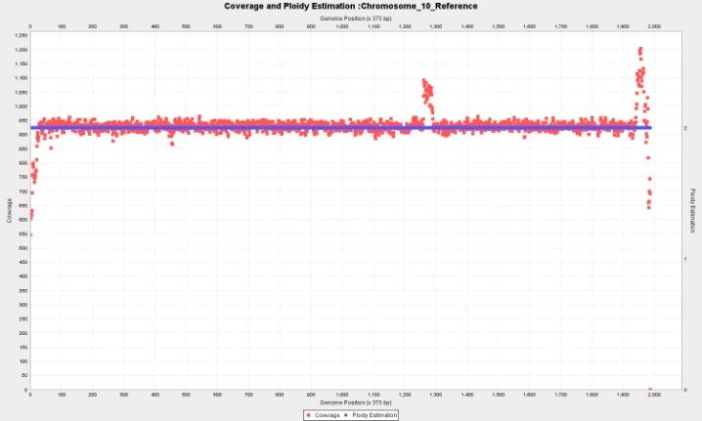

**Figure 7** Ploest outputs two different overlapped plots for each input contig. The first is a cloud of points showing the coverage of each window sliding over the different positions of the reference genome. While the coverage tends to remain constant along the contig, some variations happen notably around areas with repeats or other coverage irregularities. It also happens that some reference genomes have sections that have a different copy number than the rest of the genome, this can also be easily visualized in the contig coverage plot.

2.4.5 Inferring the read count cluster means by fitting a mixture of Gaussians

In order to be able to automatically infer the mean of each cluster, we fit a mixture of Gaussians to the read count distribution, by estimating the parameters of the mixture with an Expectation-Maximization approach.

The sum of reads starting at each step, divided by the bin’s length give us the average read count rc of each window *w*. The average number of read counts in a region with constant copy number depends on the number of reads, the length of the region and the length of the sliding window *wl*. The number of reads in such region is approximately distributed according to Poisson, Po(*λ*), (Nter Klambauer et al., n.d.) where the mean number of reads per window is *λ*, given by

$$λ=\frac{N wl}{G}$$

with *N* being the total number of reads over that region, *G* the size of the region and *wl* << *G*. Following (Xie & Tammi, 2009) we use the Gaussian distribution $Gauss\left(r_{c} | θ_{i,c}\right)$ to approximate the Poisson distribution with mean and variance *λ* = *μ* = *σ*2. This approximation is reported by Xie to work good when the mean number of reads per window is greater than 10.

The read count distribution contains all the contigs with different copy numbers, which together can be modeled as mixture of M Gaussian components. Then, the probability of a certain read count rc having a copy number of i can be expressed as:

$$p\left(r_{c}\right)=\sum_{i=1}^{M}{π_{i} Gauss(r_{c}}|θ_{i,c})$$

The mixture coefficients, or weights of each Gaussian element is given by $π_{i}$ and the Gaussian parameters $θ_{i,c}$ is given by the mean *λ* = *μ* which we estimate by Expectation-Maximization (EM). We tried setting the value of *μ* = *σ*2, as previously explained and found that the result don’t change significantly when *σ*2 is instead estimated as an extra parameter in the EM, since the objective of the fitting is to obtain the values of the means. We use the JMEF java library for managing mixtures of exponential families to implement the EM.

EM is a method to find the maximum likelihood estimate of a parameter $θ$ of a probability distribution, in this case $Gauss\left(r_{c} | θ_{i,c}\right)$. It consists of two steps…

(Describe a the principle of EM algorithm here. Include the random initialization of the first set of parameters using K-means)

This approach present some challenges. The maximum copy number that Pedca is able to detect is *Max_Ploidy* =10. By visual inspection of the read count distribution it is relatively easy to determine the correct number of clusters present in the genome. But we desire a process that is as much automatized as possible and is able to deal with very diverse genomes. While it is easy to fix most of the parameters to run the algorithm on our simulated data, we need to find ways to tune the settings to generalize our method.

One of these parameters is the sampling rate of the read count distribution which affects the goodness of the fit. More data points have higher standard variation and the algorithm tends to fit extra mixtures to try to reduce whatever error measure is used. () In order to fix this step, finding the right sampling rate is required. But the correct sampling varies with the number of final mixtures which we don’t know in advance.

**Figure 8** Small sampling in the read count distribution leads to a distribution which is easier to fit. But finding the right sampling in advance might be a challenge. 40 points are quite easy to fit when only 3 mixtures must be fit (top figure), but it doesn’t provide enough numbers for a high number of different ploidies. In the other hand, when too many points with large variation exist, the EM algorithm fit extra mixtures that don’t explain new clusters but include unexplained points. In some runs with 400 points (bottom figure) three mixtures were used to fit two big clusters. Means derived from such fit cannot be used to infer the centers.

Another important challenge is finding an appropriate measure to fit the correct number of Gaussian mixtures.

We fixed the sample rate to 40 points, which is an appropriate number for a simulated data, then run 10 fitting rounds, starting with 1 Gaussian and increasing each time the number of mixtures. We then compare all of them and try to determine when adding an extra Gaussians doesn’t add significant information to the distribution curve.

While the sum of squares due to error (SSE), the R-square (R-Sq),the adjusted R-square (adj R-Sq) and the degrees of freedom in the error (DF) measure well the fitness of the mixture to the data, they don’t serve well enough our cause since they don’t always halt the addition of new mixtures to detect the right number of clusters (Figure 9). The algorithm keeps fitting mixtures beyond the number main clusters and reducing the measured error to the existing points. Unfortunately the extra mixtures add nonexistent centers that prevent to find the correct ratio among the real ones. These measures failed to fit the correct number of mixtures (*i*=3) in our simulated data set in more than half of the time so they were discarded.

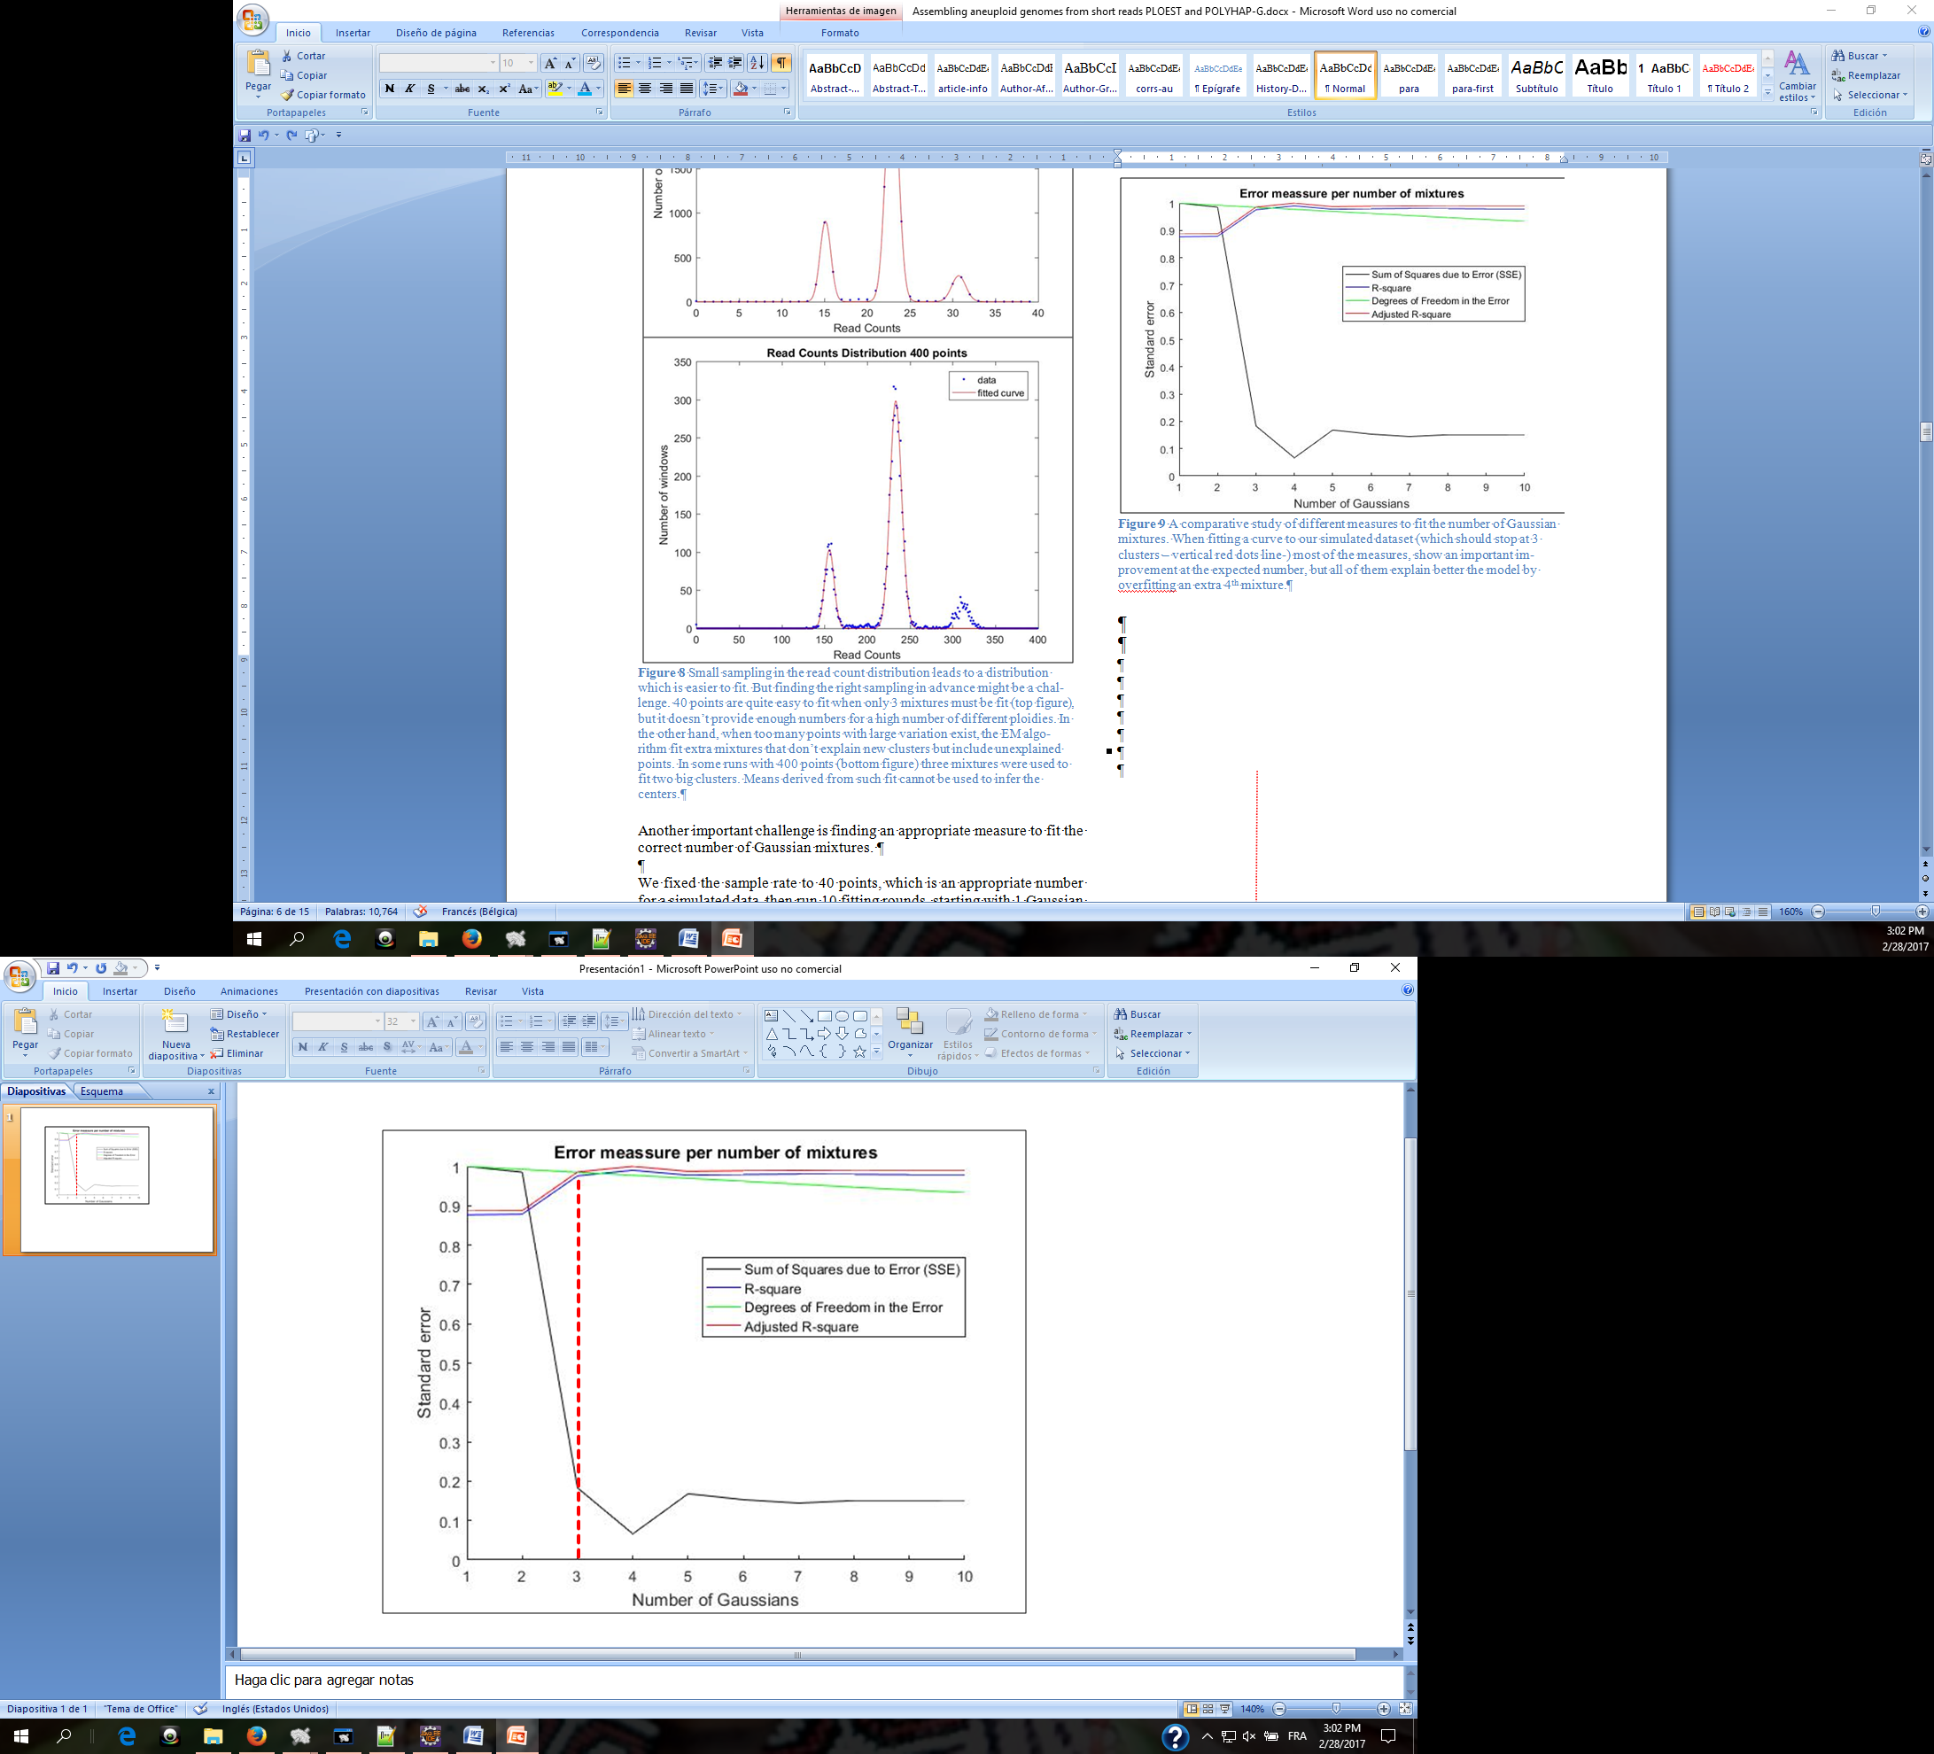

**Figure 9** A comparative study of different measures to fit the number of Gaussian mixtures. When fitting a curve to our simulated dataset (which should stop at 3 clusters – vertical red dots line-) most of the measures, show an important improvement at the expected number, but all of them explain better the model by overfitting an extra 4th mixture.

(Nijkamp et al., 2012) use the Bayesian Information Criterion (BIC) to estimate the right number of fits because it penalizes each extra parameter and tend to avoid over fitting the distribution. We measured how well the BIC worked on our simulated genome. With the EM approach we fitted 10 different models to the read count distribution, each of them with different number of Gaussians 1-10. The model with lowest BIC is then selected. We run our algorithm 1000 times which correctly predicted the copy number of the genome 82% of the time, which is a better result than any of the error measures previously described. Because the initialization of some of the EM parameters is random (like the µ’s), we might have slightly different results each time the algorithm is run ().

We decided to average the results of several runs (100), to reduce the impact of the occasional wrong predictions. With this method Pedca was able to accurately predict the copy number of our simulated dataset in 97.2% of the cases. Unfortunately the results dropped to 64.1% when real data was used.



**Figure 10** The blue curve fits the red read counts histogram of our simulated genome, with the BIC measuring when to stop adding mixtures. The result is not constant, fitting in some rare cases up to 8 mixtures, making the method unreliable to detect the clusters centers.

2.3.7 Using a naïve smoother over the read count distribution

One of the main reason why the estimation maximization Gaussian fit failed to adapt to a different data set is that too many parameters are involved into making the algorithm correctly work. The rate at which the read count is sampled, the range over which the read count number extends (the x-axe), the initialization of the Gaussians mixtures parameters in the EM algorithm, the measure to fit the right number of mixtures… All these parameters affect how the distribution is shaped and how easily its clusters can be identified. While it is relatively easy to set the parameters to solve a particular data set, it is more complicated to adapt the algorithm to work with a larger spectrum of genomes.

The final implementation of Pedca opts for a simpler approach by skipping the automatic fitting of the mixture model. Instead, the read count distribution is smoothed in a naive way by a histogram of a fixed number of bins, making the means of the clusters become the peak values of the function. Normally, even if the read count distribution can be described by a mixture of Gaussians, the real function is not a smooth curve, but a sawed continuity of values that follows a certain local tendency. By applying a smoother, the only remaining maxima are the values at the peak of the clusters. When the function is smoothed in such a way, detecting those points provides the means of the clusters. Those values have the same ratio among them than the chromosomal copy number which we can then estimate.

First we detect the limits of the x-values and decide whether it is necessary or not to reject a small percent containing extreme values (1%). This helps to delimit the region where the informative reads are, which allows the shape of the distribution to be more clearly defined and adapted to the fixed number of bins, and make the clusters easier to be identified.

Next, we proceed to transform the distribution into a histogram with cleaner tendencies. We divide the space of the abscissa in a number of bins B where some bins are turning points that we define as b*max*, where b*max-1* < b*max* > b*max+1* Since we need only 3 bins to identify a b*max*, the bin width *β* depends on the read counts range and is inversely proportional to *3*Max_Ploidy*, so that it is defined by

$$β = \frac{max⁡\{r_{c}\}}{3*Max_Ploidy}$$

with $max⁡\{r_{c}\}$ being the maximum value in the x axis. We apply a naïve smoother by setting all the values inside each bin to its average, resulting in a histogram of the read counts (Figure 11). Within each b*max* the highest value of the original distribution is then retained as the mean of that cluster. This results in n means µthat have a ratio among them that can range between 1 and *Max_Ploidy* and are all approximative multiples of the ploidy unit read count (PURC*)*. The PURC is the inferred read count of the basic cluster that serves as unit to the segments with ploidy higher than one and is defined as the maximum common denominator of all µ ().



**Figure 11** The original blue distribution with irregular values is smoothed by bin segmentation with within averaged values. The result is showed in the red histogram. The red frames indicate the bins with maxima value. Searching back in the original distribution for the maxima value within those windows identifies the centers of each cluster (red dot lines at 156, 233, 312). In this example the PURC (green dot line) is identified around the value 78, and the existing copy numbers cluster around the ratios of 2x, 3x and 4x that value, which in turn, are the copy numbers found in this sample

2.3.8 The ratio model score

In order to infer the optimal PURC, a score is given to each of the ratios that could explain the ensemble of observed read count peak values as defined previously by *R={$r_{1}$, $r_{2}$, $r_{3}$,… $r_{n}$}*. We can also define the ploidy read count unit as the hypothetical $r_{0}=ρ$ that better explains all the members of *R*. The final ploidy estimation will be the ensemble *P*=*{$p_{1}$, $p_{2}$, $p_{3,}$… $,p_{n}$}* defined by

$P=\{\frac{r_{1}}{ρ}$*, $\frac{r_{2}}{ρ}$… $\frac{r_{n}}{ρ}$* } $=R/ρ$

Of course, we don’t know $ρ$ beforehand but we know that it is a fraction $r_{1}/j$ with ranges between 1 > *j* > ${Max}_{ploidy}$. Since Pedca deals with ${Max}_{ploidy}$ = 10 it is feasible to compute all possible values of $ρ_{j}$. The ensemble $R_{j}$ of theoretical potential clusters given by a candidate $ρ_{j}$ is

$R_{j}=\{1,2…$ ${Max}_{ploidy}\}*ρ_{j}$

Not all of the possible clusters of $R_{j}$ exist, only those that can be mapped to the actual peaks observed in *R* are retained. The values $r$ ∈ $R$ that minimize the distance between themselves and the theoretical multiples of $R_{j}$ give us the model explained by the candidate $ρ_{j}$

$$R_{j}^{'}={argmin }_{r∈R} \{\left|\left|R_{j}-R\right|\right|\}$$

Each model $R_{j}^{'}$ has a score $σ_{j}$ which is given by the total distances between the observed clusters and the candidate model. The distances are normalized by the length of the contig *c*

$$σ_{j}= \sum{\frac{|\left|R_{j}^{'}-R\right||}{c}}$$

At the end the model with the smallest score $σ_{j}$ is retained and the corresponding $ρ_{j}$ is the PURC

2.3.9 Dynamic window length

We’ve described how Pedca runs a sliding window of length *wl* over the length of each contig, to measure the depth of coverage at each step. Until a certain extent, a bigger *wl* often provides a smoother averaged value of the read count for each window, resulting in a plot with less variations, and more clearly distinct clusters. This might be very helpful when identifying the ratio between the clusters and the PURC.

In the other hand, a very high *wl* value provides fewer points to define the coverage of a contig. Some contigs might be even shorter than the ideal window length, which would mean that we wouldn’t have any coverage points at all to estimate their ploidy.

To address this, Pedca runs a first round with the initial window length provided by the user or the default value, preferably a large value (depending on the size of the contigs it might be between 1Kb to 10 Kbp) If necessary, *wl* is dynamically adapted to solve the remaining contigs in a second round with a smaller size.

In its current implementation, the new window length is computed by keeping track of all contigs that could not be solved with the initial size, then running a second round with a new window based on the size of the smallest unsolved contig $min⁡\{L\}$. The new window length is given by:

$$wl'=\frac{wl}{1.25*c*min⁡\{L\}}$$

Where $c$ is a parameter that insures that the ploidy estimation points are constant over a certain number of windows. This parameter *c* will be described in detail later (2.3.8). c is multiplied by the constant 1.25 to ensure that the new window length provides enough coverage points to estimate a ploidy on the smallest contig. The smallest new window length accepted is 16 bp.



**Figure 12** The curve resulting from adding two Gaussians with overlapping tails might offset the center of their means. This potentially ends up affecting the inference of the ratio unit (PURC).

2.3.10 Solving ambiguous copy numbers.

The window size might also affect the smoothness of the read count distribution. When the function is too irregular or spiky, the smoother might wrongly classify some peaks as a separate cluster. A similar complication might arise with clusters of high ploidy. Each cluster builds around a multiple of the ploidy unit read count (PURC), and follows a Gaussian distribution. The sums of Gaussian distributions have the property that each time they add up, their mean adds up and so does their standard deviation. A cluster of µ=5 and σ=2 will result in a x2 multiple of µ=10 and σ=4. This has more effect on the clusters with high copy number. The standard deviation of their distribution might overlap their tails, potentially displacing their centers to each other, and out of phase with the corresponding theoretical multiple of the PURC. This might result in a wrong estimation of the PURC, and therefore in a erroneous ploidy estimation () The added variation of sum of Gaussians effect reflects also on the coverage plots, with depth point clouds being more dispersed as the ploidy increases (See supplemental material)

In order to disambiguate these difficult ploidy estimations, we added an extra feature. If provided with an input variant call file (.vcf), Pedca measures the proportion of the allele frequencies in those contigs with ploidy corresponding to the first cluster. Those contigs have the smallest ploidy possible ( $p_{1})$ of the whole genome and are assumed to be $1 ≤p_{1}≤4$. The shape of this distribution provides additional information about the ploidy of these contigs (). A diploid contig will have only one peak, since most variations will have only two alleles, the shape of the proportion will cluster around ½ (0.5 value).



**Figure 13** Typical Allele frequencies shapes for a diploid contig (left figure) are build around 0.5 value, for a triploid (center figure) around 0.33 and 0.66 values, and in the case of tetraploids, (right figure) around 0.25, 0.5 and 0.75.

A triploid will show most proportions around the 0.33 and 0.66 values (1/3 and 2/3). A tetraploid will show three peaks around 0.25 0.5 and 0.75 values (¼, 2/4, and ¾). In order to do this, Pedca stores all contigs that have an estimated copy number corresponding to the first identified cluster. Because some contigs might be aligned to chromosomes that have structural variations within them with different copy number, only those contigs with contiguous ploidy estimation are stored. This leads to less noise in the base call distribution plot.

Before plotting, Pedca remove the base calls above 90% and those below 10% to ease the read of the shape. Since we consider that all first clusters will have a ploidy between 1 and 4, and therefore those variations are considered errors or non representative.

The plots analysis provides an extra element of information to the ploidy inference. The base call of a contig with $p_{1}$ =1, doesn’t have a particularly recognizable shape because only a small set of random variations or errors will be registered in the .vcf file. For this reason, we output also the second cluster distribution ${ p}_{2}$, which will always be $p_{2}$ ≥ 2

2.3.8 The output

Pedca outputs two overlaid plots for every input contig. The first is a cloud of points showing the coverage of each window sliding over the different positions of the reference genome. While the coverage tends to remain constant along the contig, some variations might happen, especially around areas with repeat content. It also happens that some reference genomes have sections that have a different copy number than the rest of the genome, this can also be easily visualized in the contig coverage plot ().

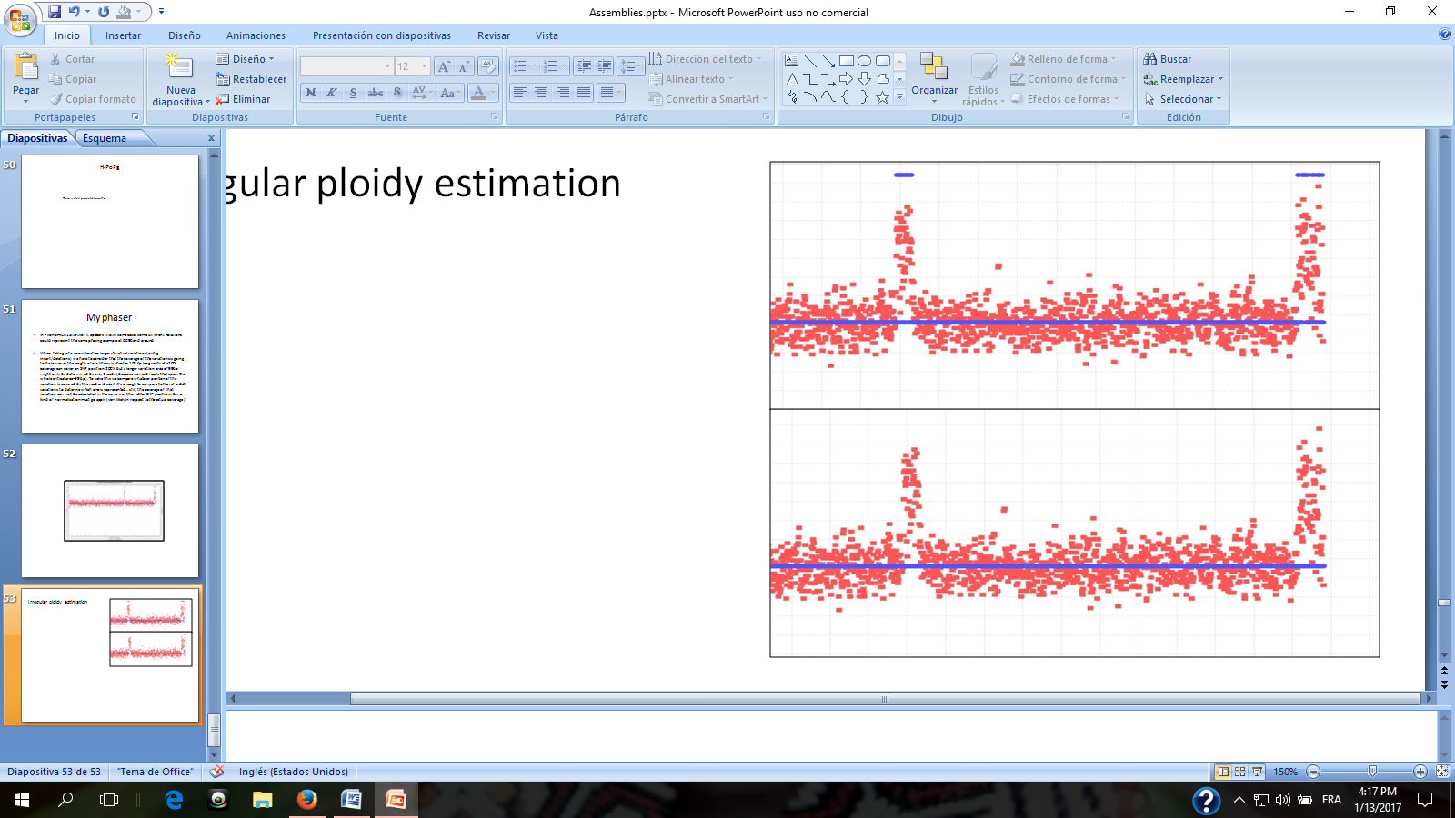

**Figure 14** Computing the mode over different k contiguous ploidy estimation points. If k is too small it might lead to fragmented ploidy estimation in regions with noisy coverage (top) The continuity is smoothed with the right k value (bottom k=50). The correct length of k depends on the required precision, and can be parameterized. If k is too big, it might lead to the non detection of regions with different ploidies (i.e. large structural variations found in hybrid genomes)

The second plot that Pedca outputs, for those contigs with enough data, is the corresponding copy number estimation over the coverage cloud. Each ploidy estimation point pi is computed by rounding the ratio of its corresponding coverage read count point ri over the PURC. The ploidy estimation plot reflects the same irregularities that the coverage plots sometimes have, so we smooth the ploidy estimation points. Simply averaging them over k different positions doesn’t always work, because the average might be a point that doesn’t reflect any real ploidy present in the genome. For instance a contig with copy number mixture of 2 and 4 copies, might average erroneously to 3 over some regions. We choose instead the mode of the ploidy over k contiguous windows, with k being set at 50 windows by default but being a parametric value (). Theoretically the worst precision γ of the ploidy estimation that can be expected occurs when the dispersion over the k windows is at its higher, and the mode is represented only by 1/*Max_Ploidy* data points. Since each data point is taken every window length *wl*/2

$$γ=\frac{k*wl}{2*Max_Ploidy}$$

It is important to underline that this theoretical worst case precision depends also on the reliability of the coverage data. When the window length is too slow other factors will affect the coverage that is reported by the alignment. Some regions with a higher repeat content will have a sudden increase in their coverage. Small window sizes will result in more data points defining a given region. Other regions with high variation rate might overrun the capacity of the aligner to map the reads to the appropriate draft reference resulting in coverage rates improperly reported. In those cases, the mode over a few windows might not be accurate enough to smooth inconsistent depth values. This is why $γ$ can also be given by the user and adapted to the specificities of the genome.

Pedca outputs a .txt file describing in detail the different regions of each contig that have different ploidy estimation. Before deciding that a given fragment has a change in its ploidy, Pedca makes sure that at least a certain number of continuous data points bear the same copy number estimation. This intends to avoid erroneous estimations in inconsistent data sets. If not enough continuity is ensured by the data, Pedca breaks the contig into fragments and output an estimation only for the segments for which it has enough evidence. By default that number is *c*=20, but can also be defined by the user. Only fragments with continuous ploidy over more than φ bp will be reported.

$$φ=\frac{c*wl}{2}$$

2.4 Phasing

In this paper we define a haplotype as the nucleotide sequence along a single copy of a chromosome. Because the chromosome might have more than just a copy, each haplotype will have a very similar sequence of nucleotides, but with its own specific variations at certain loci. Phasing or haplotyping is the process of clustering together the variations that belong to the same haplotype, which defines the correct nucleotide sequence for each chromosome copy.

(Motazedi, Finkers, Maliepaard, & de Ridder, 2016) evaluated the performance of 3 state of the art haplotype estimation algorithms for polyploids: HapCompass (Aguiar & Istrail, 2012), HapTree (Berger, Yorukoglu, Peng, & Berger, 2014) and SDhaP (Das et al., 2015), with different levels of sequencing depth, ploidy levels and genomic diversity, using tetraploid potato as the model. His conclusion is that sequencing depth is the major determinant of phasing reconstruction quality, that 1kb PacBio CCS reads and Illumina reads with large insert-sizes are competitive, but that all of the exiting methods fail to produce good haplotypes with increase in ploidy.

Phasing diploid (references in page 2 of Motazedi) different from Polyploids because in diploids the alternative variant is always present in the other allele.

Computational complexity of haplotype reconstruction increases rapidly with an increase in ploidy.

When representing different haplotypes of a same chromosome, we can ignore the homozygous regions and only consider the variant sites. For a chromosome with k variants, we can represent its haplotype as a string from the set {A,C,G,T}. Even though the possibility of tetra-allelic variant exists, it is generally assumed that variants are bi-allelic. We can therefore represent haplotypes as a string from the set {0,1}, where 0 and 1 represent the two possible allelic values at each variant location.

The objective behind our approach is to tackle the polyploid haplotyping problem avoiding to have to compute all possible combinations of SNP’s which is computationally very expensive. Most methods don’t avoid the exponential approach. Instead, they find ways to reduce the computational complexity by coding strategies, mostly by dynamic programming.

The exponential problem arises when, in order to separate the reads that have errors from those which really describe the different haplotypes, all possible variant combinations are computed, then by some method, usually a most likelihood approach, the most likely combinations are retained, and the other discarded.

Here, we explore the possibility of avoiding the computation of all variant combinations by removing the error variations before clustering the remaining ones in the correct number of haplotypes. We have the advantage that, thanks to Pedca, we can infer before hand, the exact number of copies per contig that we are looking for. The idea is to only consider the error free variants that are supported by the reads, and cluster them in the number of haplotypes given by Pedca.

Our explration uses as input a .sam/.bam file with all the reads aligned to the reference genome, and the .vcf files with all the variants of the reads aligned to their references. The vcf file reports all variations relative to the provided reference, found in the available libraries. The reads might contain sequencing errors and alignment errors and our objective is to discard them.

The basis of our approach is to first identify all positions where variations are detected. A .vcf file stores the percentages of different alleles present per position respect to a draft reference. Because we know the expected number of haplotypes *p* per contig, we can discard the variations that don’t reach a certain threshold of presence 1/2*p*. This means that the kept detected variations represent at least one copy of the reference. We end up with a list of positions where enough variations are detected to discard errors. We also keep track of the actual SNP’s that can be observed. We can represent all the observations as a vector of paired positions *l* and the observed variations *v* at those positions

*O*=($l_{1}\left|v_{1}, { l}_{2}\right|v_{2},{ l}_{3}|v_{3}… l_{n}|v_{n})$.

Since we have different libraries of paired ends with diverse insert sizes, the possibility of connections between distant variation loci is bigger, but not enough to insure coverage for all possible combinations. Our situation becomes an optimization problem.

The next step is to store the information of the reads that support such variations at those particular positions. We want to know which reads support each of the possible variations at the concerned loci, but we are also interested in knowing which variations are represented together in the same read.

We create a matrix *H* of dimensions *i* x *j* with all observations $O_{i=1→n}$ in the rows and all observations $O_{j=1→n}$ in the columns, and store at each intersection $H_{ij}$ the reads that support their simultaneous co-observation.

The read being aligned to a reference may have inserts or deletions that are not in the reference. The CIGAR string is a sequence of base lengths and the associated description of the read alignment to the reference. They carry information like which bases align (either a match/mismatch), which are deleted, and/or which are insertions that are not in the reference. In order to define precisely the loci where an observation should be observed we need to reverse the way in which the read was aligned to the reference, then compare the sequence at the precise loci and store it. We use the CIGAR of the bam file to fill the different intersection of the matrix. If an observation in a read doesn’t match any of the identified paired loci/variation, that segment of the read is considered a sequencing or alignment error and is rejected. When a position in the read describes an alternative present in the matrix, the read has a match in the corresponding column of H. We then record the read identifier in every row of every other co-observed variation.

We can look at the result as an adjacency matrix of a graph of localized variations, in which the nodes describe the alleles and the edges, the co-observation of two variations in the same read. The number of reads recorded at each intersection $H_{ij}$ is the weight that supports a connection between two variants.

The solution to the phasing problem is to color the graph with a number of different colors equal to the expected ploidy. Each color represents an haplotype. The challenge is to find a way to color the graph in an optimized way. There are a few particular properties of our graph that can help us solve the problem.

First, some variations will be exclusive to one color/haplotype. This is certain for diploids and triploids and we assume that there will always be some exclusive variations in higher polyploids.

… describe the phasing algorithm here…

# Results

### 3.1 Ploidy estimation with Pedca

3.1.1 Results on the simulated genome.

After aligning with bwa-0.7.13 all of the simulated reads to the simulated genome (the first copy of each chromosome is used as reference), we obtain the .bam file that we use as input. Pedca’s results on our simulated genome are very promising. Pedca correctly predicts the ploidy of each chromosome with the default window length. The read count distribution has clearly distinct clusters and this over a very large range of different window sizes, including very large ones ().

The naïve approach successfully identifies the different clusters even with very large window sizes (up to 100 Kb, see supplemental material). Because of repeated regions and other coverage irregularities over the sequence, a small window length sometimes leads to breaks in the continuity of the coverage data points, leaving the corresponding ploidy estimation points in blank. Pedca reports only those segments for which it has information and tracks the starting and end points of those segments, even if this leads to a more fragmented report.

If we measure the precision of the ploidy estimation by summing up the length of all the correct fragments estimation over the totality of the genome (3.6 Mbp) and how it is affected by the window length we see that from very small window sizes (50 bp) to very large ones (100 Kb) the result vary very little and that vast majority of the genome’s ploidy is correctly predicted (). All of the lengths predict correctly more than 99.5% of the totality of the genome. Let us remember that a small Structural Variation (SV) of 10 Kb was introduced in Chromosome 3 giving to one of the alleles a different copy number. This is the 0.27 % of the genome that remains unrecognized with window sizes bigger than the threshold $φ$ calculated with (formula reference to $φ$)



**Figure 15** Percentage of all of the simulated genome with ploidy estimation and percentage correctly predicted under different window lengths. Mostly all of the genome (+99.98%) had an output estimation (whether correct or not). All window lengths detected at least 99.52% of the genomes ploidy correctly. With sizes beyond the threshold that detects the 10 Kbp deletion introduced in chromosome III, the percentage of correctly predicted genome remains constant since the SV is not recognized.

In the same way, we measure and add the amount of each chromosome that is covered by the ploidy estimation

With windows bigger than its corresponding threshold φ=10000 bp all the genome is covered. With shorter windows, only a small amount of fragments (+/- 0.02%) are not covered by the estimation. The difference between the covered region and the correct prediction corresponds to the segments that are wrongly predicted. This value ranges between 0.48% with the smallest wl=50 bp and ≈0% with the optimal wl=750 bp. The constant 0.27% difference after the φ threshold corresponds exactly to the SV, which means that except for that deletion the rest of the genome is correctly predicted.

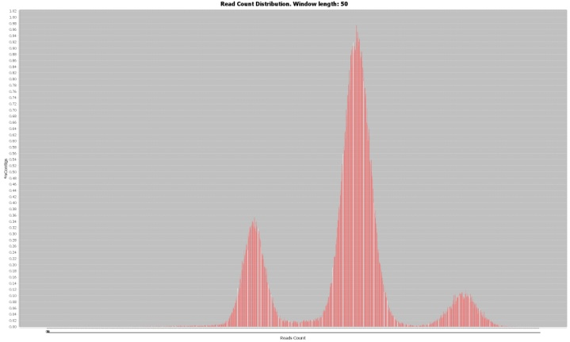

**Figure 16** With very small window length, the dispersion of the data points increases to the point where the clusters can become very difficult to identify. With our simulated genome, very clearly distinct clusters are obtain even with a very small window size of 50 bp.

It is also interesting to measure the sensibility of the ploidy estimation by fragments. (). The simulated Chromosome_3 was built with a copy number of 4 but with a small SV in one of its haplotypes consisting of a 10kb deletion (from 306000kb to 316000kb) a few base pairs before the end of the sequence (See supplemental material).

We measure how much of that segment is correctly detected and estimated. The theoretical precision of the ploidy estimation by fragments depends on the window length, as we’ve have defined in the methods section. But the real precision depends also on the reliability of the coverage. The fluctuation in coverage can be the result of something else than a change in copy number. They might reflect a segment that is highly repeated over the genome and show higher or lower depth that the reference fragment really has. This is often the cases in the regions at the beginning and end of the chromosomes. In other cases, it might also reflect less coverage than the one expected, for instance if the region has more variation that the one that can be recognized by the alignment tool that generated the .bam file.

We measured how well different window lengths detected the SV introduced at the end of chromosome 3 of our simulated data, a region very prone to coverage irregularities.

Figure Different window lengths affect differently the dispersion of the coverage data which in turn determine the precision of the copy number estimation. In our simulated chromosome 3, the small structural variation is detected with window lengths of 700 and 750 bp. The smallest window provides too many points with an important amount of dispersion that increases the fragmentation of the ploidy estimation. A window of 750 bp smoothes the dispersion by averaging the coverage over larger segments. Above wl=1000 bp the SV is not detected.



**Figure 18** Percentage of the introduced Structural Variation introduced in Chromosome III that went undetected by Pedca or had a wrong estimation under different window lengths. Under the threshold that allows the detection, wl= 750 bp has most of the deletion correctly identified. Very small windows wrongly predict the ploidy of the SV, mostly because the coverage is highly fragmented.

The results show that window lengths smaller than 1.000bp (which theoretically would be the maximum φ allow to detect the 10.000 bp SV that we introduced), are able to detect from 42% up to 92.5% of the deletion fragment, depending on which window length is used. The best result is obtained with *wl*=750 bp which identifies correctly 9.250 bp of the deletion without missing any fragment of it. A very small window length of 50 bp gives too many data points with too much standard deviation, which leads to an irregular ploidy estimation that only detects 42% of the fragment (Figure 18). With windows higher than 1.000 bp the deletion is beyond the threshold that allows it to identify it.



**Figure 19** Different read count distributions with different window lengths on the Baseclear sequencing. From top to bottom: wl=100, 750, 3.500 bp and 40 Kbp. The shortest windows have too much standard deviation, joining clusters with different copy number to the point where they cannot be recognized anymore. As the window size increases, the clusters become more subtly defined and recognizable

3.1.1 Results on the CBS Baseclear genome.

Our simulated genome results serve only as proof of concept. The simulated data is neat and clean which is rarely the case with a real genome, but we can be confident that the principles on which it operates work correctly. We next apply our method to two real data set of S.pastorianus CBS1483, the Baseclear genome and a very noisy assembly from which Magnolya could not make sense of (Novogene). The S.pastorianus CBS1483 genome that is used as reference in both cases, consist of 59 contigs with a total length of 22.3 Mbp. While all the contigs are bigger than 500 bp, the average size is 378.8 Kbp ranging from the largerst (1,464.6 Kbp) to the smallest (526 bp). The N50 is 750.1 Kbp (Van den Broek et al. 2015)

On the Baseclear sequencing, windows smaller than 500 bp lead to very ambiguous groups in the read count distribution, where only two clusters can be recognized once the histogram has smoothed the tendencies. The smaller windows lead to less distinct clusters with a bigger amount of overlapped tails. Yet, Pedca can operate if it identifies correctly at least the first two clusters of this sequencing P={1, 2}. Once the PURC is correctly inferred, the rest of the process can estimate all contigs copy numbers, by computing its ratio relative to the coverage ( top).

Using the window size that best worked on our simulation (wl=750 bp) we obtain a read count distribution that displays 3 clusters ( center), but they are less clearly distinct in the Baseclear sequencing. The reported ploidies are P={1, 2, 3}. The groups join their tails, specially the second and the third one, which indicates that a certain amount of regions will have ambiguous coverage. The last clear cluster has what falsely appears to be a long tail on its right side. The 43 contigs solved in the first round report 63 fragments of different ploidy estimations. This is one of the least fragmented reports (77 fragments) very close to the best one (wl=500bp; 71 fragments).

Here, the adaptable window feature proves to be very helpful since the second round solves 8 additional contigs with 14 extra fragments which results in 51/59 contigs ending up with a copy number estimation. The 8 unsolved contigs are explained by the low quality of the coverage information they have: very few points with a high degree of depth variation (See supplemental material)

Here, the adaptable window feature proves to be very helpful since the second round solves 8 additional contigs with 14 extra fragments which results in 51/59 contigs ending up with a copy number estimation. The 8 unsolved contigs are explained by the low quality of the coverage information they have: very few points with a high degree of depth variation (See supplemental material)

With *wl* ≥ 3.500bp what seemed to be a long tail in the third clusters, start to reveal two small clusters corresponding to a little percentage of the reads with higher copy number regions ( bottom). The ploidies now reported are P={1, 2, 3, 4, 5}. There are two exceptions to this that happen with very large window sizes. The bias in the deviation of the clusters due the sum of Gaussians effect described previously, provide a report of ploidies P={2, 4, 6, 9} with wl=20 Kbp, and the sampling with a extremely big size of wl=75 Kbp result in very irregular read count distribution that recognizes false peaks, resulting in a report of P={2, 4, 5, 6}. In both cases, the allele frequencies plot determines that the second cluster has ${ p}_{2}=2$ and therefore the first one ${ p}_{1}=1$ which validates the most reported estimation P={1, 2, 3, 4, 5}.

We run Pedca with a large range of different window sizes and found that the peaks were correctly fitted and recognized even with such large lengths as wl=75 Kbp (see supplemental material). The wl=6.000 bp detects a false peak in the read count distribution that prevents Pedca to find a logical ratio explanation. When those case happens, Pedca stops to run, and a message in the main output file warns the user about the situation and prompts him to run the program again with a different window size.

The current implementation runs a first ploidy estimation with an initial window length, then runs a second one with a new size adapted to the smallest contig. This feature helps to estimate 8 extra contigs on the Baseclear sequencing. As we described before, the idea of a second round is to allow a first large window length, which helps sampling the read count distribution with more smoothed values resulting in more distinct clusters and a higher reliability of the infer PURC. Yet, there is another limitation to the size of the first window length. When a contig is not sampled with enough coverage points in the first round, it is left to be solved in the second one. But the second window length is adapted to the smallest contig, and if too long contigs left, a short sampling bin will provide too many points and will lead to a high standard deviation in the coverage cloud and a very fragmented and less reliable copy number estimation. This is particularly the case when the contig lengths of the reference sequence have a big standard deviation, and Pedca has to deal with both very large and very short contigs at the same time.

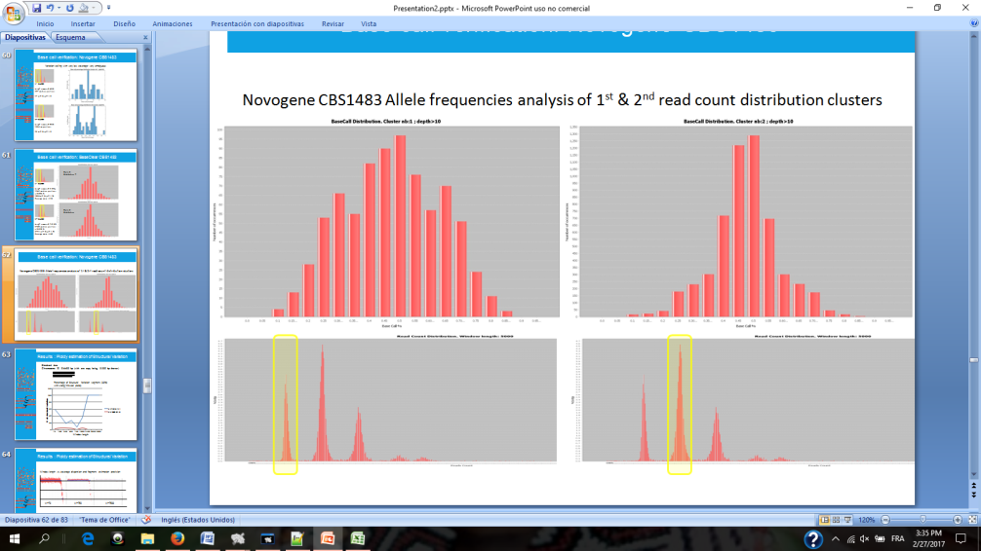

**Figure 20** Allele frequency analysis (top figures) for Novogene CBS1483 shows the base call percentages of the variations found in reads from the first and second cluster of the read count distribution (bottom). Here we have a good example of the utility of plotting the second cluster, since the first plot (left) corresponds to ${ p}_{1}$ =1, the shape is not distinct enough to be recognizable and could easily be mistaken for ${ p}_{1}$ =2. The second cluster (right) could never have ${ p}_{2}$ =1 (only the first cluster can), and it is more clearly shaped around the 50% bin, indicating a ${ p}_{2}$ =2. Results are similar on Baseclear CBS1483

shows the fragmentation in the first and second round with a range of initial window lengths going from very small (50bp) to very large (75 Kbp). The details of the plot are also available on the supplement section in the form of a table. The less fragmented estimations are obtained with sampling bins within the range of 400bp to 3.500bp. With original wl’s < 400bp, the breaks in the contigs of the first round are higher than those in the second. The few contigs that are left for a second round have small size and can easily be estimated with the small wl. But as the original wl is set higher, and specially above 5.000 bp, bigger contigs cannot be solved in the first round. When sampled with the second wl, too small for them, their coverage variation is too high leading to very fragmented and unreliable ploidy estimations. As the original wl increases, so do the second run number of breaks. The plot shows that the region where the breaks from the first and the second round cross each other correspond to the range of ideal window sizes that lead to the less fragmented estimations. The final copy number inference for the Baseclear sequencing will combine estimations made with wl=400, 500, 750 and 1000 bp (Supplemental material)



Figure 21 Ploidy estimation fragmentation by window length for Baseclear CBS1483. The figure shows that the best size range for getting the most continuous estimations are between wl=400 bp and wl=3.500 bp. Ploest could not run with wl=6Kbp, and two bins estimated a ploidy twice as big as all the others (wl= 20 Kbp and 75 Kbp)

3.1.1 Results on the S.*pastorianus* CBS1483 Novogene.

Overall, the results on the Novogene sequencing don’t differ much from the Baseclear except that they are. This is at the same time expected, but surprising at the same time since this dataset was too noisy for previous methods (Magnolya).

Results from Novogene show ploidy estimation for up to 52/59 contigs.

Curiously a ploidy of p=3 is estimated for Scaffold 55 (741 bp) whose data wasn’t continuous enough in the Baseclear sequencing to allow a copy number output.

By looking at its fragmentation per window length plot we can see that the dataset is more prone to clusters detection errors, failing to infer a proper ratio with wl= 75, 100 and 20.000 bp ending with an invitation to try another window length. As for the Baseclear sequencing, the copy numbers more often reported are P={1, 2, 3, 4, 5}, (where ${ p}_{2}=2$ and ${ p}_{1}=1$) but with the Novogene set of reads, we have a more frequent report of a basic ploidy = 2 (wl= 9, 30, 40, 50 and 75 Kbp). This only occurred twice with the Baseclear dataset. The allele frequency analysis could disambiguate the ploidy with the same result than in the Baseclear sequencing.

We obtain the same convex plot showing more fragmented reports with small and big window sizes, but the convexity is more accentuated than in the Baseclear sequencing. This means a higher resistance to extreme window lengths (specially the shortest ones) in terms of fragmentation which suggests that the Novogene data has less standard variation than the Baseclear.



**Figure 22** Ploidy estimation fragmentation by window length for Novogene CBS1483. Best sizes for getting the most continuous estimations are similar to Baseclear. Pedca could not run with wl=75bp, 100 bp and 20 Kbp, and five bins estimated a ploidy twice as big as all the others (9, 30, 40, 50 and75 Kbp)

A comparison of the coverage and ploidy plots between the two datasets (see supplemental material) confirms this analysis. This is quite surprising because we were considering Novogene CBS_1483 to be a more noisy dataset with more expected standard variation than its Baseclear counterpart. The more compact coverage data also explains why it is possible to infer the copy number of contig 55, with this data set (as well as other small fragments from different scaffolds).

If we output a selection of the less fragmented estimations with different sampling sizes, and we compare it with the Baseclear estimations we notice some minor differences. Some additional fragments that were not estimated previously are identified here. In Contig 35 a small sequence, from position 224 Kbp to 229.5 Kbp (+/- 1.225bp) is estimated with p=4 where no ploidy was previously estimated. Another unidentified segment at the end of contig 43 is identified with p= 5. Contig 50 display constant p=1 with Novogene, but a dubious small change is detected with Baseclear of p=2. This could also be explained by the difference between both data sets’ standard variation.

Much more spectacular and clear is a divergence in contig 24. This scaffold is 652 Kbp long and its size limits much more the copy number difference being explained by simple data standard variation. While the Baseclear genome has a clear p=1, the Novogene outputs a solid estimation of p=2 over the whole extent of the scaffold. This scaffolds map to Chromosome X of Eubayanus and May be this corresponds to a recent mutation in the strain sequenced by (Possible explanations??: New mutation, different strain? Doesn’t look like an error!!)

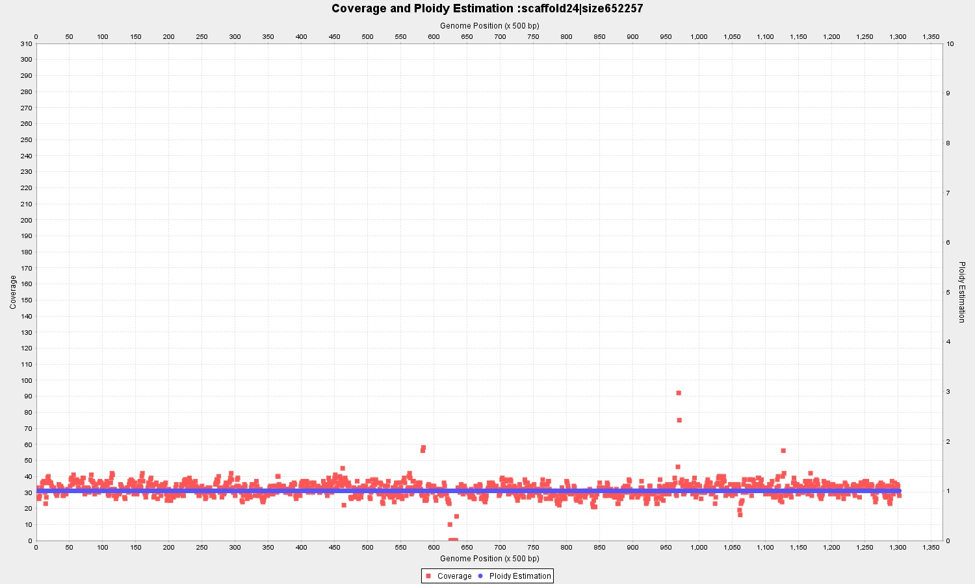

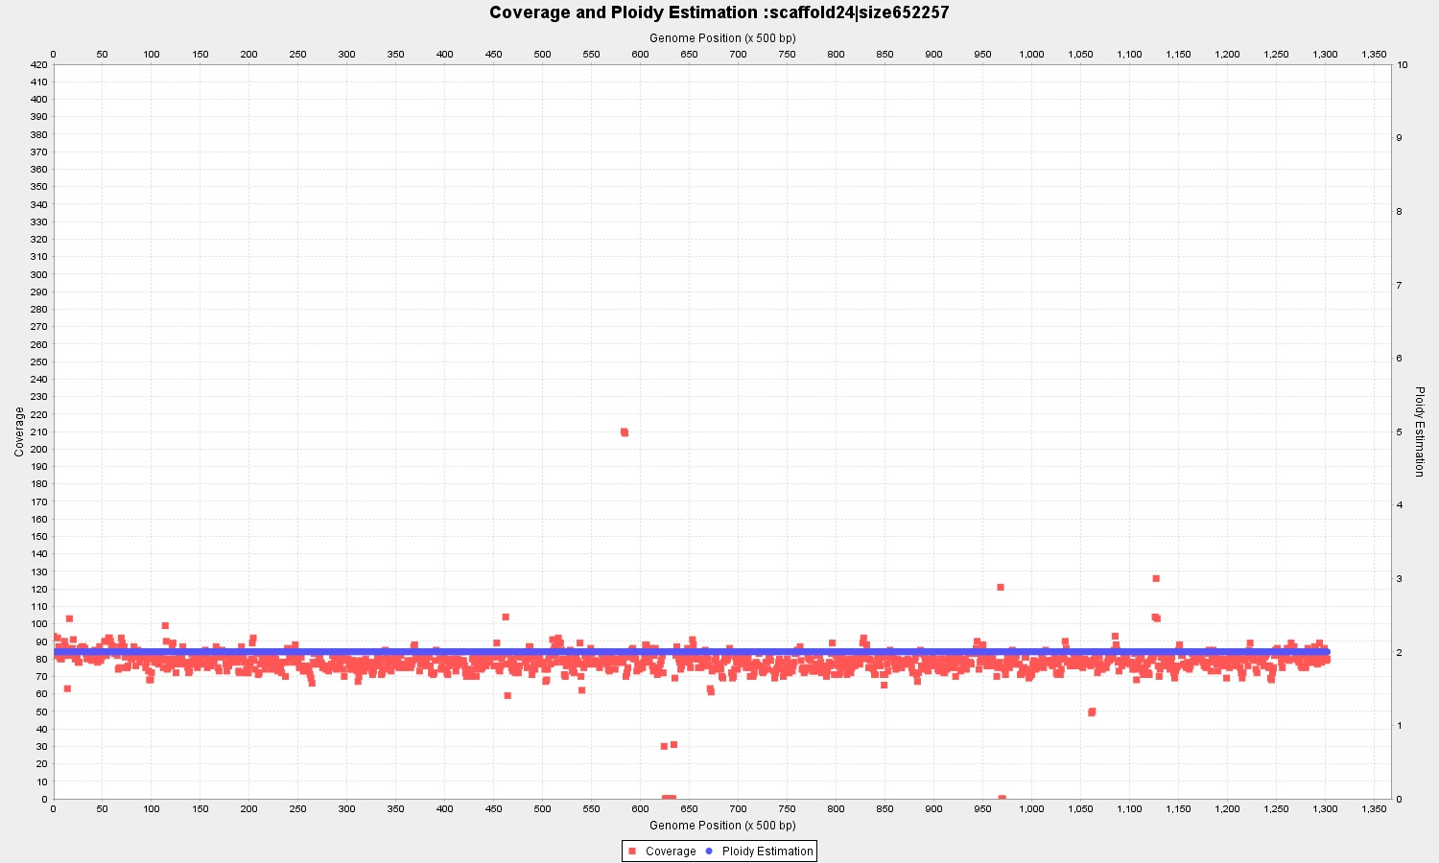

**Figure 23** Baseclear (top) and Novogene (bottom) reads aligned to the scaffold 24 displaying a different ploidy of 1 and 2 respectively. It is the only whole contig for which the two sequencings differ.

### Trypanosome Cruzi genome

Trypanosome *cruzi*, a triatomine parasite (also known as a "kissing bug") is the infecting agent of the commonly known chagas disease. Symptoms of the infection can include fever, flu-like symptoms, a rash or swollen eyelid. Early symptoms usually go away but if untreated, the infection can cause serious intestinal and heart problems(Ley, Andrews, Robbins, & Nussenzweig, n.d.)

T.cruzi’s genome is not well known. One strain, the T.cruzi CL Brener which belongs to one of its lineage, TcVI, is also the result of an hybridation of two related ancestors: the TcII and TcIII lineages. A sanger reference genome was published in 2005, generated by whole genome shotgun with Sanger reads (El-Sayed N. et al., 2005).

The genome has a high repetitive content of about 50% of its size. Its ploidy is currently unknown and about 1/3 of the assembly consists of non assigned contigs (~36 Mbp) that have not ye be mapped to any of the ancestors haplotypes. It is an extremely noisy data set on which we can test the limits of our method.

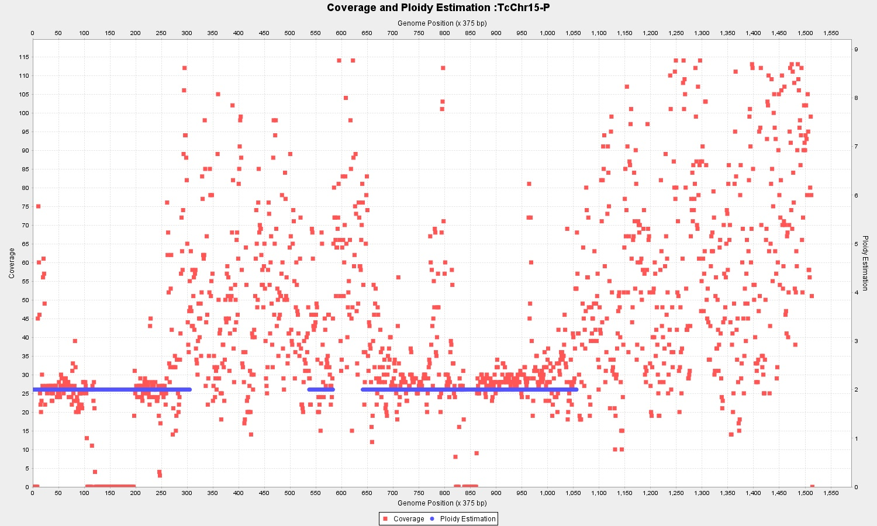

**Figure 24** T.cruzi Illumina library mapped to TcIII-like (Chromosome 15). While some areas can be identified, big segments with very high coverage variability due to repeated sequences, make the estimation very unreliable.

We first map Illumina paired end reads (2 x 150bp) to the respective 40 pseudochromosomes references of the two ancestors known as Esmo-like (TcII) ~35 Mb and Non-Esmo like (TcIII) ~32.5M bp scaffolded by (Genomics, Weatherly, Boehlke, & Tarleton, n.d.) in 2009. The highly repetitive content makes the ploidy estimation very difficult, and even if we can identify some areas with defined and continuous coverage, the results remain very fragmented and ambiguous.(Figure 24)

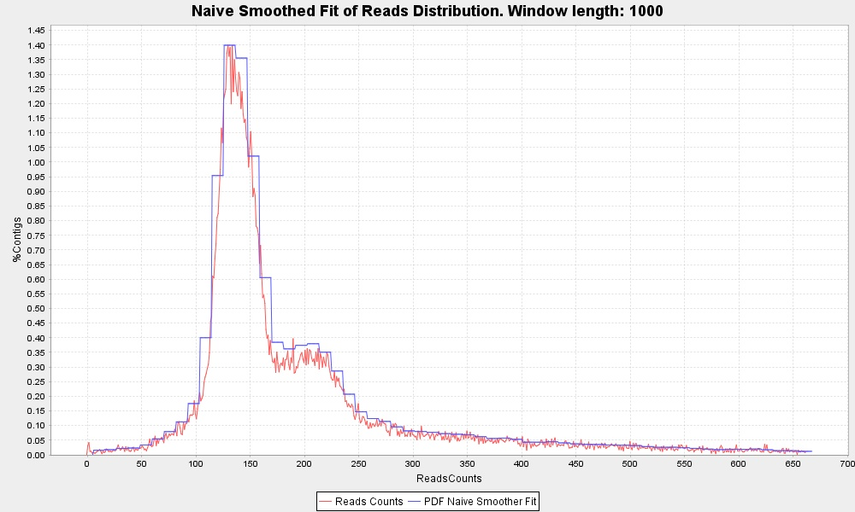

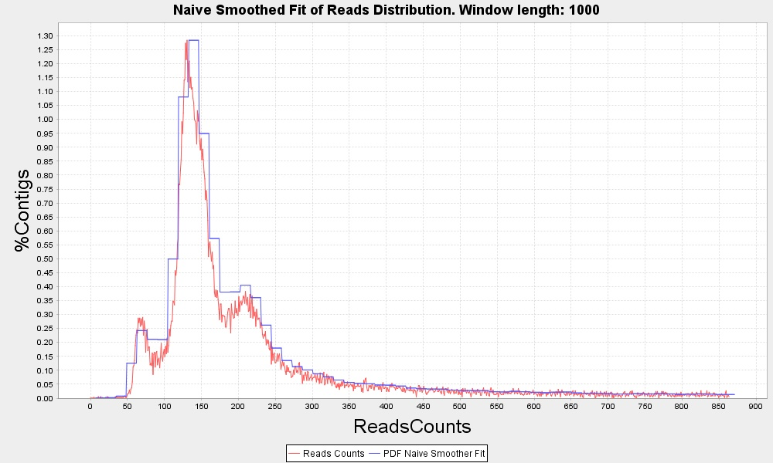

**Figure 25** Read count distribution for T. cruzi. Similar to the TcIII strain, the esmo- like alignment (top figure) results in two clusters that are usually recognized as ploidies 2 and 3. The same reads aligned to the BroadTcVIPacBioassembly (bottom figure) reveal a third cluster corresponding to p=1.

Mapping to either of the ancestor genomes results in very similar outputs. Trying to improve our results, we tested aligning the reads, to an assembly of the Hybrid strain TcVI, instead of the two ancestors separately. We use an assembly from PacBio reads sequenced by the Broad Institute of MIT and Harvard. We’ll refer to this reference as the BroadTcVIPacBio assembly. Since the assembly has 2.697 contigs we choose to try our method using only the 50 longer sequences as reference. The results are still noisy but much more clear and contiguous than the two ancestors.

The read count distribution of the separate ancestors has two similar clusters that were commonly identified as ploidy 2 and 3. The BroadTcVIPacBio reference allows the identification of a third cluster corresponding to p=1 () This corresponds with the individual estimations of the contigs. While most of the scaffolds are diploid, a considerable number seem to be triploid and some of them haploid (Supplemental material)

It is worth underlying the utility of the adaptable widow size in the analysis of the different contigs which most often benefits from having different sampling sizes to compare results. Contig 16’s coverage in the BroadTcVIPacBio alignment shows higher variability than its fellow contigs and with wl=1000 bp it is still difficult to determine the overall ploidy (). By switching to a higher wl=5000 bp the estimation is clearly defined as p=3 with data points averaged over a longer length.

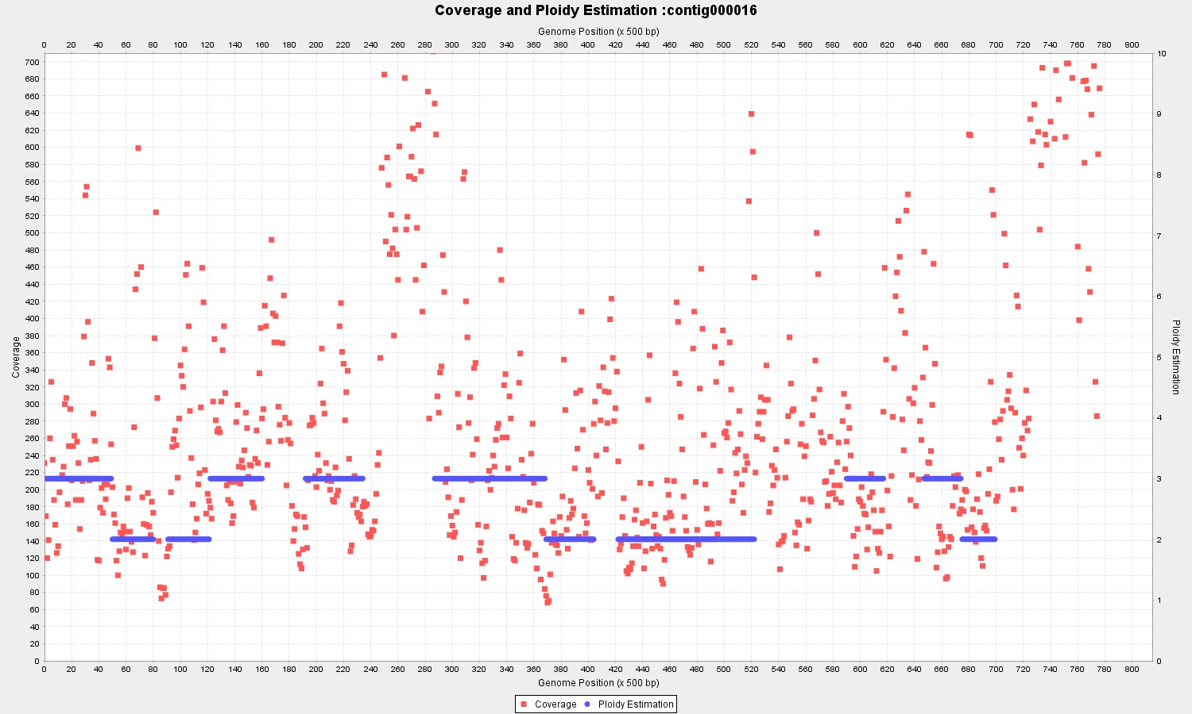

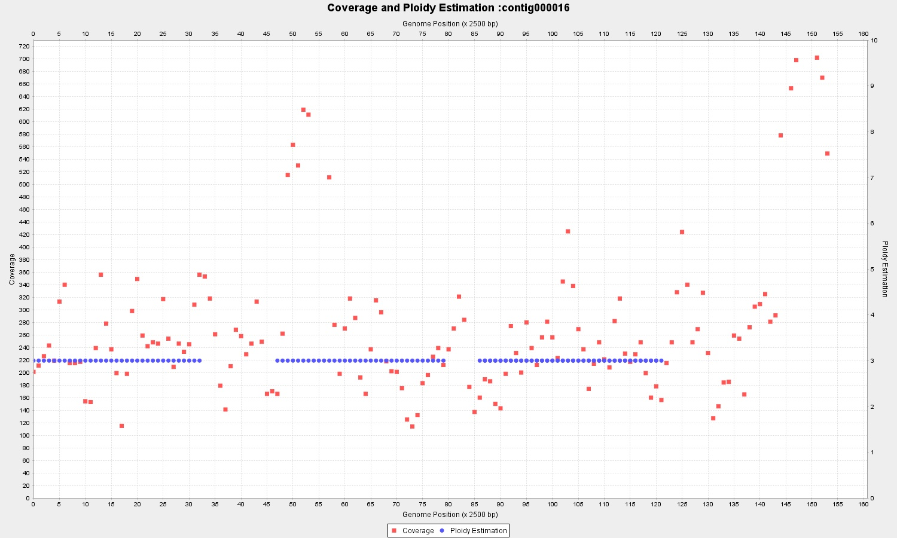

Figure Running the algorithm with a range of different window lengths is useful for tuning the ploidy estimation. The analysis of Contig 16 of BroadTcVIPacBiowith wl=1.000 bp (top) is more ambiguous than with wl= 5.000 bp (bottom)

### 3.1 Phasing results with Pedca

Discusion

We’ve proved the utility of the dynamic window length feature by implementing a second round of coverage sampling. Next step is implementing a method that increases the flexibility of the window length and specially customizes to each contig size.

Sometimes a window length is on the threshold to allow a contig to be solved on the 1st or the second run. When long contigs are just a little bit too small to be solved in the first run, and the window is adjusted to solve contigs much shorter, the estimation of the longest contigs to be solved in the second run have too many data and variation to be solved properly. This would also be solved by a more flexible window.

For contigs smaller than 1000 bp having a sliding window might not be so useful. The length of the contig itself is larger than the threshold to detect a fragment with different ploidy. In such cases it is probably a good idea to implement a feature that averages the coverage over the whole contig when this happens. The irregularities over the sequence would be smoothed and the risk of losing fragments with changes in ploidy should be acceptable for such a small size.

In order to compare estimations from different window lengths we need a measure to evaluate each estimation. This measure has to take into account different elements: The standard deviation of the coverage cloud around each different ploidy estimation, the different ploidy estimations within a single contig, and the proportion of the contig that is estimated in relation to the total length of the sequence. The measure should also take somehow into consideration the density of the data points/sampling. With such measure it will be easy to compare the output from different window lengths for the same contig and chose the best result. The algorithm could then run without requiring other input than the .bam file, simply by running a spectrum of preselected window lengths, then choosing for each contig the best customized ploidy estimation among all available. This would be relatively easy to implement in the next version of Pedca.

Another useful feature to implement in an utterly version of Pedca would be an automatic recognition of the frequency allele distribution, so that the software can run itself automatically when it detects a wrong coverage to ploidy ratio. The second run would force the PURC induced by the variation analysis.

Conclusion

Reflexions

Challenges,

Lessons

Improvements

Direction

..develop…

Acknowledgements

The quick brown fox jumps over the lazy dog. The quick brown fox jumps over the lazy dog. The quick brown fox jumps over the lazy dog. The quick brown fox

References

Alexandrescu,A. (2001) Modern C++ Design: Generic Programming and Design Patterens Applied. Addision Wesley Professional, Boston.

Dormand,J.R. and Prince,P.J. (1980) A family of embedded Runge–Kutta formulae. *J. Comp. Appl. Math.*, **6**, 19–26.

Alexandrescu,A. (2001) *Modern C++ Design: Generic Programming and Design Patterens Applied.* Addision Wesley Professional, Boston.

Dormand,J.R. and Prince,P.J. (1980) A family of embedded Runge–Kutta formulae. *J. Comp. Appl. Math.*, **6**, 19–26.

Alexandrescu,A. (2001) *Modern C++ Design: Generic Programming and Design Patterens Applied.* Addision Wesley Professional, Boston.

Dormand,J.R. and Prince,P.J. (1980) A family of embedded Runge–Kutta formulae. *J. Comp. Appl. Math.*, **6**, 19–26.

Yoo,M.S. *et al*. (2003) Oxidative stress regulated genes in nigral dopaminergic neurnol cell: correlation with the known pathology in Parkinson’s disease. *Brain Res. Mol. Brain Res.*, **110**(Suppl. 1), 76–84.

Crenshaw, B.,III, and Jones, W.B.,Jr (2003) The future of clinical cancer management: one tumor, one chip. *Bioinformatics*, doi:10.1093/bioinformatics/btn000.

Auhtor,A.B. *et al.* (2000) Chapter title. In Smith, A.C. (ed.), *Book Title*, 2nd edn. Publisher, Location, Vol. 1, pp. ???–???.

Bardet, G. (1920) Sur un syndrome d’obesite infantile avec polydactylie et retinite pigmentaire (contribution a l’etude des formes cliniques de l’obesite hypophysaire). PhD Thesis, name of institution, Paris, France.

http://polyploidy.org/index.php/Parade_of_Polyploids